System Menus:

The opening scene of the game shows a menu (Figure 1 ) with three choices for the player, these can be accessed by pressing the interactive buttons.

1. The first option is for a “New Game”, which transfers the player to a new scene where a character can be created.
2. The “Resume Game” button takes the player to the saved game screen where it is possible to choose from previously saved games.
3. This is the “Options” button which changes to a scene with different game options available for the game. The player can change the sound settings and difficulty settings for the game here.

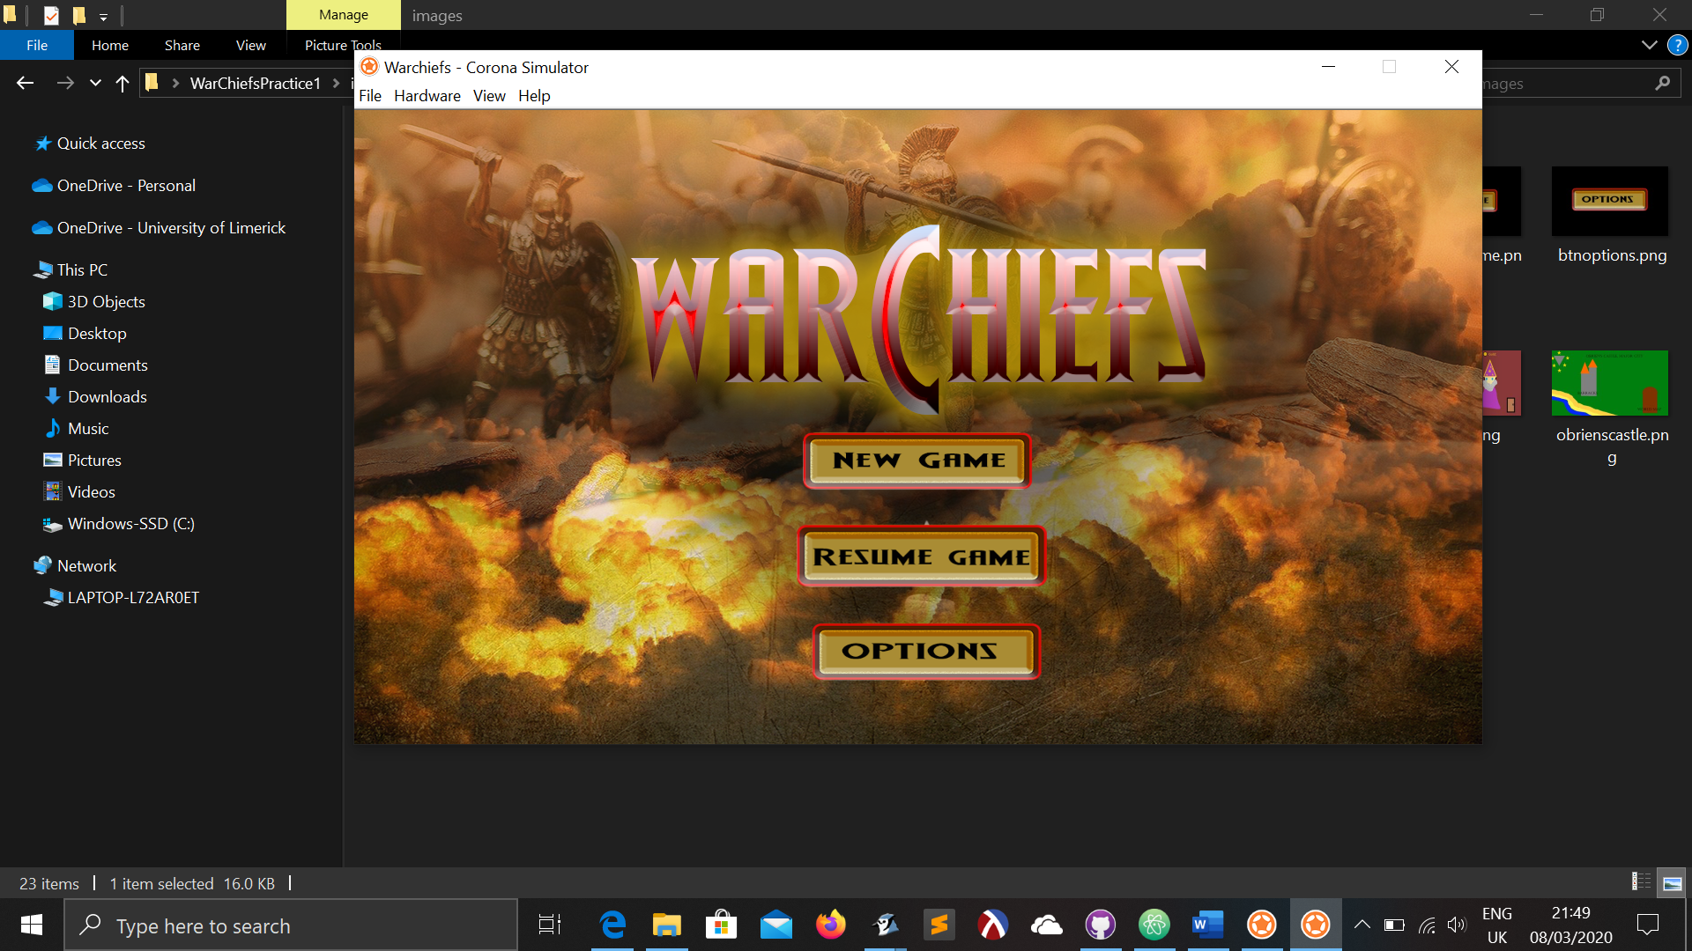

Figure 1

The game begins with a new menu (Figure 2 ) where the player creates a character using the options available.

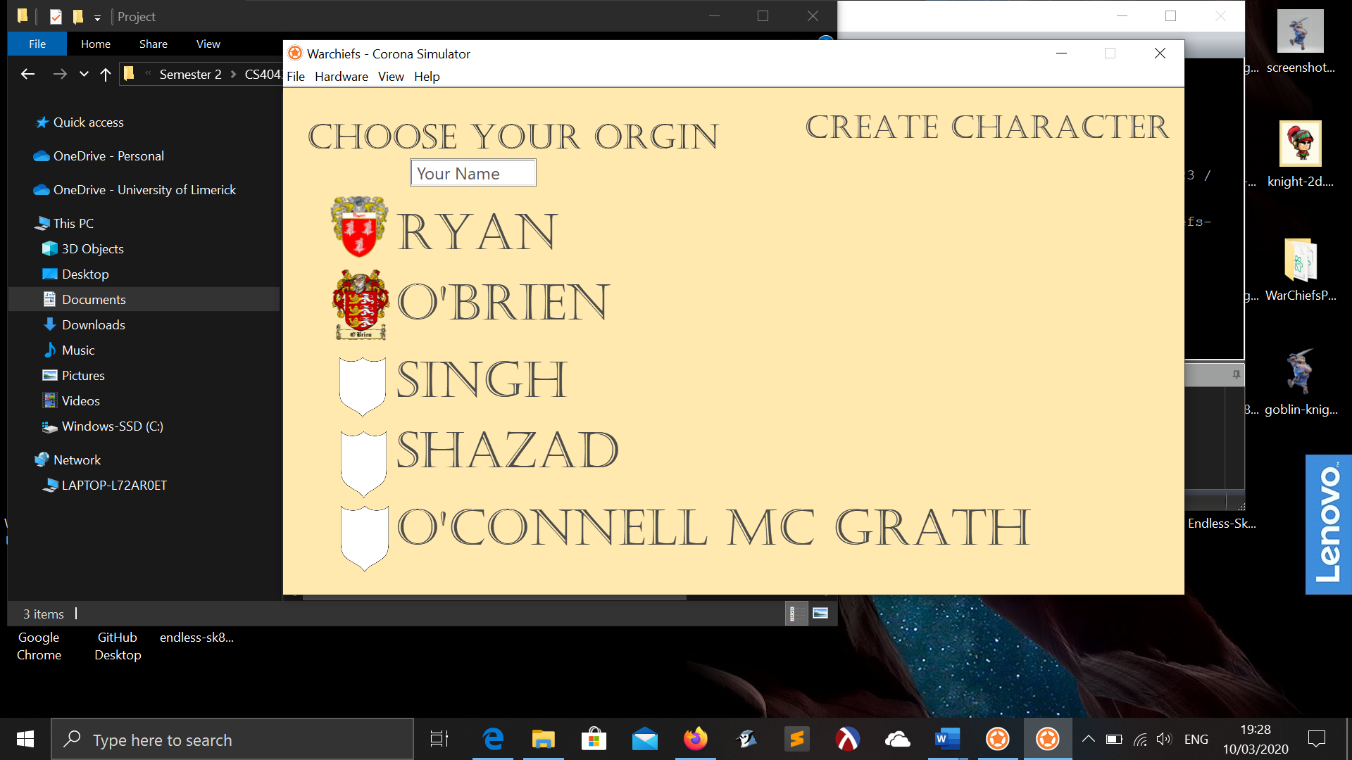

Figure 2

The next screen is the character creation screen with a system menu (Figure 3 ) to choose a name, gender, and the option to distribute attribute points.

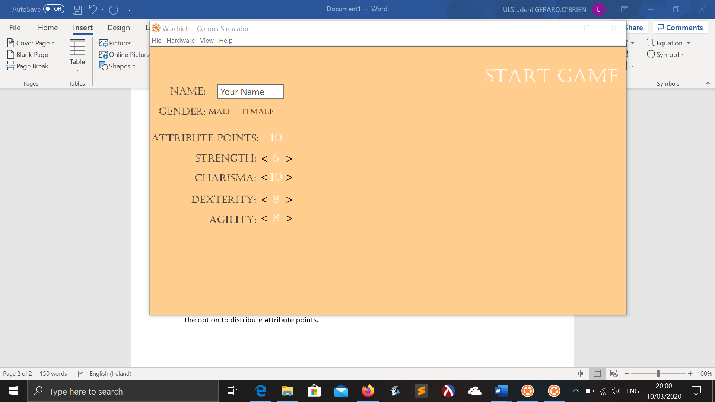

Figure 3